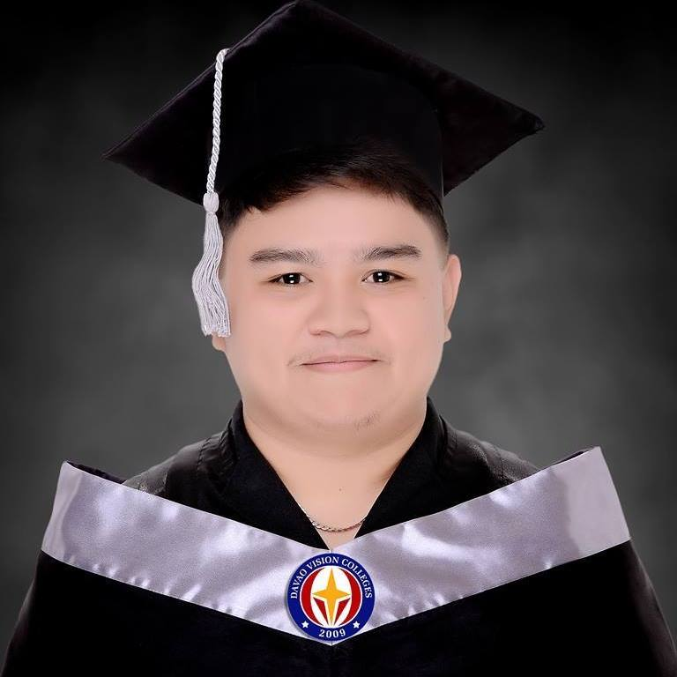

**CECILIO FREDERICO DETICIO**

**WEB DEVELOPER**

|  |  |
| --- | --- |
| **C O N T A C T**  09282150443  ceciliofredericodeticio@gmail.com  Sta. Martha Sitio Pelomina,  Catalunan Grande Davao City,   Davao Del Sur Philippines  **P R O F E S S I O N A L E X P E R I E N C E**  **Full Stack Web Developer,**  Visual Insight Multimedia and Technology Solutions (February 2018 - Present)  *In-charge in developing websites/applications, maintaining backend servers and Managing Databases used for the websites/applications.* | **C O M P E T I T I V E Q U A L I F I C A T I O N S**  **Hard Skills:**  Front End Development   (HTML, CSS, JavaScript, ReactJS, and React Native)  Back End Development (NodeJS, PHP, and MongoDB)  Basic knowledge in Game Development (Unity)  Basic knowledge in Multimedia (Image manipulation and   Video Editing)  Basic knowledge in 3D Modeling  **Soft Skills:**  Problem-solving skills necessary to handle complex problems that require analytical thinking and problem-solving skills; identify issues, troubleshoot code, and find efficient solutions to ensure smooth website functionality.  Attention to detail that thoroughly and accurately complete  task with focus and precision.  Adaptability to new technologies and frameworks emerging; open to learning new tools and techniques to stay updated and meet evolving project requirements. |

|  |  |
| --- | --- |
| **E D U C A T I O N**  **Bachelor of Science in Information Technology**  Davao Vision Colleges, Inc. | **C O M P E T I T I V E S K I L L S**  Website Development (Front and Back-end)  Responsive design and mobile optimization  Testing and debugging |